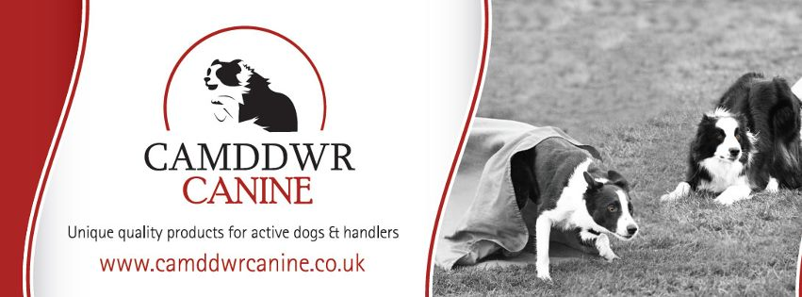
*NEW*Raw Food for Dogs
All food below is sold in easy to use sausage packets, and is human grade meat
Pricelist
Pure Beef tripe 70p 11b
Pure Lamb Tripe 70p 11b
Chicken Mince (with bone) 65p 11b
Beef (econ) 70p 11b
Game mix (with bone) 70p 11b
Heart 80p11b
Lambs Liver 80p11b
Lamb mince (econ) 7511b
Chicken Wings 95p 11b
Chicken Thighs £1.10 11b
Pigs Trotters £70p each
Chicken Carcass’ £70p


Natural Instinct – Stock items (other items can be ordered)
Sold in convenient plastic tubs – this complete raw food has been balanced for you and includes bone, Veg and Salmon Oil. Some varieties contain Offal
Working Puppy £3.10kg
Working Beef £3.00 kg
Working Chicken £2.50 Kg
Working Turkey £2.75 Kg
Working Duck £3.00 Kg
Working Chicken and Tripe £3.00 Kg
All food can be collected from Camddwr Farm or postage can be arranged at an extra cost
Camddwr Canine Ltd
Camddwr farm
LLandegla Road,
Llanarmon Yn Ial
CH74QX
01824 780522
Email sales@camddwrcanine.co.uk
www.camddwrcanine.co.uk
Unique Quality Products
For Active Dogs and Handlers!

